**Lab 7: Magnetometer - Making a Compass by MingSeg**

650:361 Introduction to Mechatronics

Team Members: Shivani Topiwala, Nancy Contreras, and Pamela Pajarillo

**Introduction**

For this lab, we will be measuring the components of the earth’s magnetic field using the HMC5883L magnetometer.

**Part 1) Obtaining Magnetometer Data**

In order to obtain data, we first created the following diagram in Simulink.

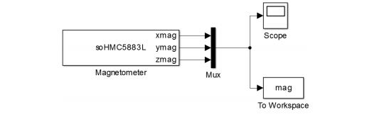

***Figure 1***

This circuit will have three outputs, x, y, and z. It will also display all data collected in Matlab. This allows us to analyzed the data.

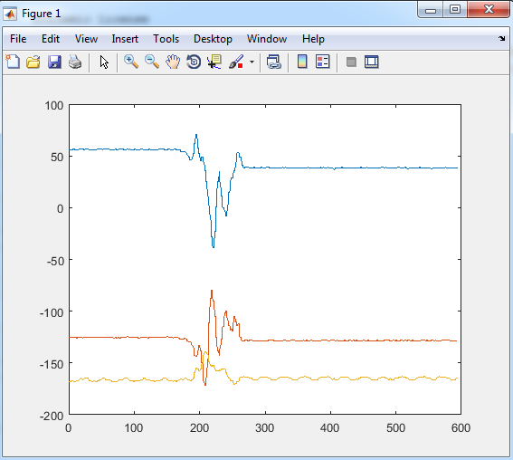

***Figure 2: Graph of x, y, and z magnitudes***

This is the graph of the magnitudes of the x, y, and z points as the sensor was moved randomly. We did this to test if our sensor was collecting accurate data. The blue line is x, red is y, and yellow is z.

**Part 2) Experimental Data and Analysis**

***Figure 3: Graph of Magnetometer Data when Moving Sensor in X and Y Only***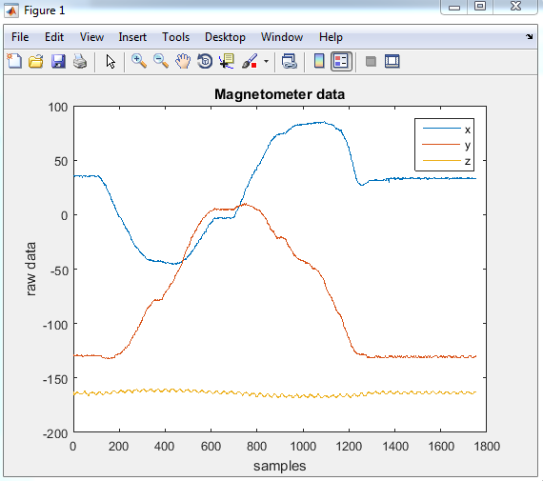

Above is the data we obtained from moving the sensor in a circle changing the x and y data points only. We just rotated the sensor on the flat table so as not to change the z direction points.

***Figure 4: Graph of Magnetometer Data of X and Y Only***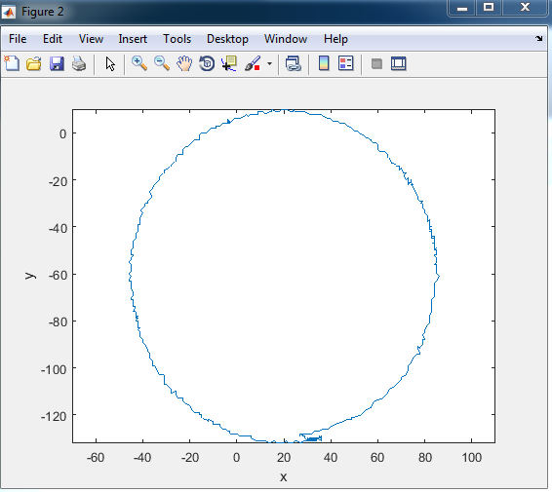

These are our points that we manually found from the circle we graphed.

Left: x:-46, y:-60

Top: x:20, y:10

Right x:85, y: -59

Bottom: x:21 y:-131

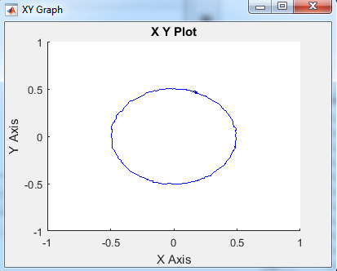

***Figure 5: Graph of Magnetometer Data of X and Y After Scaling***

We used the points we manually found from our circle graph and used it in the Matlab code provided to shift our data so the center is at our origin and scale our data so it looks more circular. The Matlab code basically got rid of the “bad” data points and made it more circular.

***Figure 6: Graph of Compass Heading***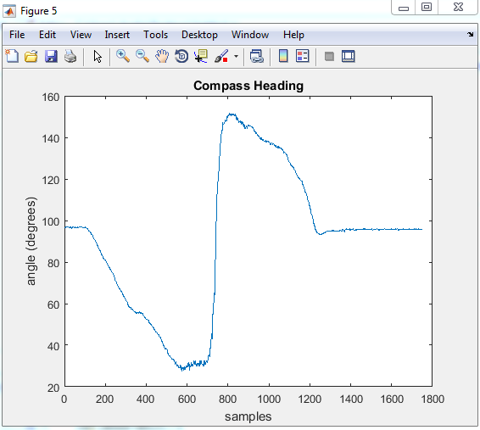

We used the arctan function to find the angle of the circle. Then we used the give Matlab code to to calibrate the compass. In general this type of calibration routine would be automated to shift and scale the data appropriately. The heading changes from 0 to 360 degrees as expected.

**Part 3) Implementation In Simulink**

***Figure 7: Simulink Model of Compass Algorithm Developed on Matlab***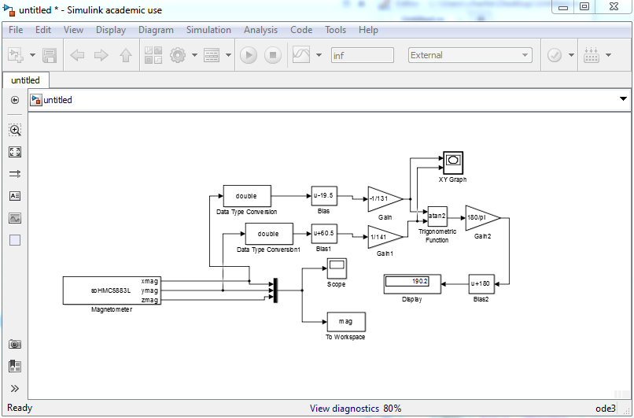

Here is the Simulink Model we developed of the same compass algorithm we developed on Matlab. Only difference is that this is can be implemented in real time by deploying it to the hardware. The XY Graph can used used as a “compass” now.

**Checkpoint:**

We verified that the display shows the correct heading – zero for north, 90 for east, 180 for south, 270 for west by changing our Gain to -1/dx so in our case -1/131.

**Conclusion:**

In this lab, we learned to make a compass using the Magnetometer. We learned how to first make the algorithm in Matlab. Then we also learned to make a Simulink Model of it to be able to use the compass in real time. Both versions have their benefits and it was interesting to learn both ways.